EXPERIMENT-10 DHILIPAN M
22/07/2026 192411038

A SEARCH ALGORITHM
AIM:
To write a Python program to implement the A* Search Algorithm for finding the shortest path between a start node and a goal node.
ALGORITHM:
Step 1: Represent the graph with edge costs and heuristic values.
Step 2: Initialize the open list (priority queue) with the start node.
Step 3: Calculate the evaluation function f(n) = g(n) + h(n), where g(n) is the path cost and h(n) is the heuristic value.
Step 4: Select the node with the lowest f(n) value from the open list.
Step 5: Expand the selected node, update the costs of its neighbouring nodes, and add them to the open list if necessary.
Step 6: Repeat until the goal node is reached, then display the shortest path and total cost.
PROGRAM:
from queue import PriorityQueue
graph = {
'A': [('B', 1), ('C', 4)],
'B': [('D', 5), ('E', 2)],
'C': [('F', 3)],
'D': [],
'E': [('G', 3)],
'F': [('G', 2)],
'G': []
}
heuristic = {
'A': 7,
'B': 6,
'C': 4,
'D': 5,
'E': 2,
'F': 2,
'G': 0
}
start = 'A'
goal = 'G'
pq = PriorityQueue()
pq.put((heuristic[start], 0, start, [start]))
visited = set()
while not pq.empty():
f, g, node, path = pq.get()
if node == goal:
print("Goal Found")
print("Path:", " -> ".join(path))
print("Total Cost:", g)
break
if node in visited:
continue
visited.add(node)
for neighbor, cost in graph[node]:
if neighbor not in visited:
new_g = g + cost
new_f = new_g + heuristic[neighbor]
pq.put((new_f, new_g, neighbor, path + [neighbor]))
else:
print("Goal Not Found")

OUTPUT:
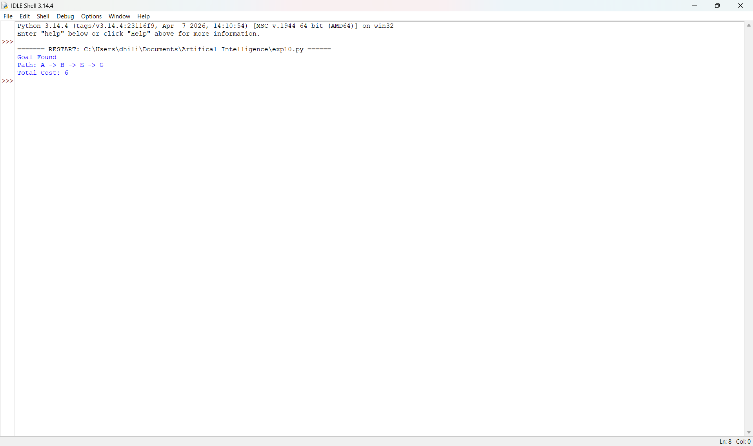

RESULT:
Thus, the Python program to implement the A* Search Algorithm was implemented successfully and the required output was obtained.

